New South Wales WEIGHTLIFTING  STATE REFEREE COURSE  When  Sunday 19 February 2017  10.00am – 1.00pm  Where  CrossFit Hunter  Barbell Club  122 Garden Grove Parade Adamstown (Newcastle) NSW 2289  Register online by 15 February 2017 www.nswweightlifting.com.au |  |  | 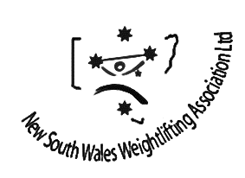  PRESENTED BY  Linda Eades  NSWWA Technical Coordinator  EVERYONE WELCOMe  Free to 2017 NSWWA financial members  $50 for non-members (money to be paid on the day)  Iwf rule book and other course material supplied  Email leades@plc.nsw.edu.au with any questions  